NT2C Run N’ GUN

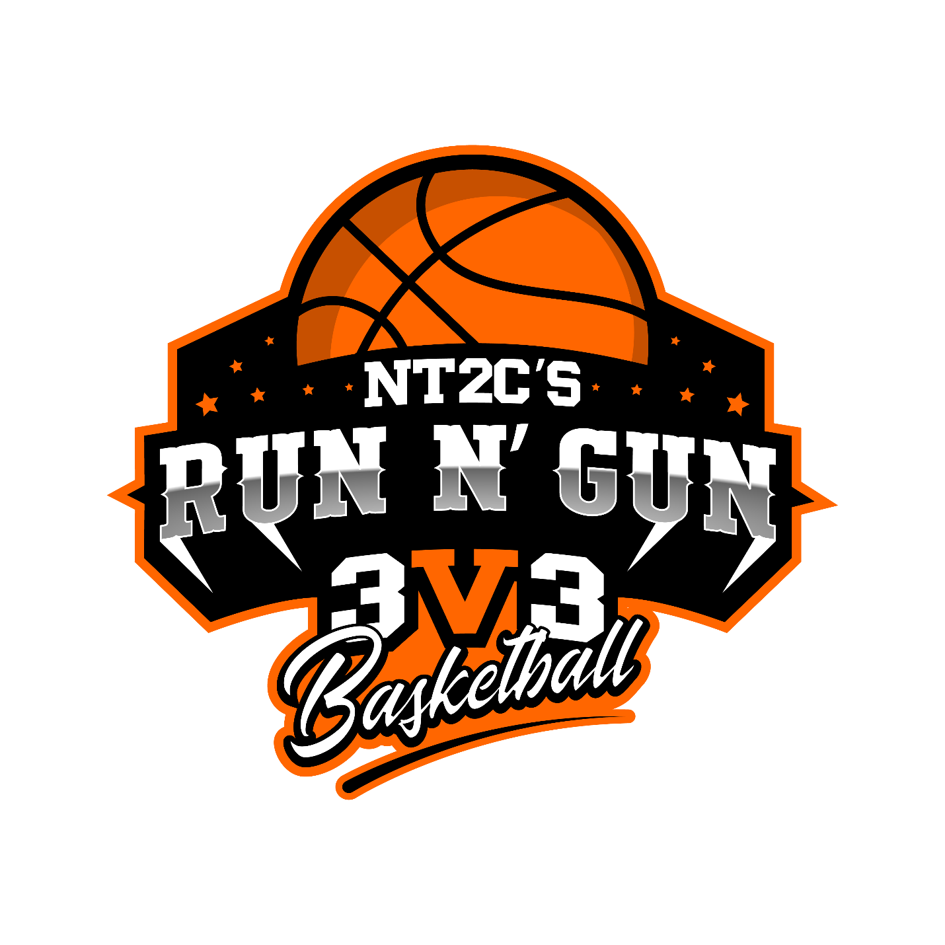

**Team Players:**

6 players per team

**Game Start:**

Paper/Rock/Scissors

**Game End:**

Time expiration

**Time limit:**

Two (2) Qtrs. 10 minutes Running Clock

**Half-Time:**

Two (2) minutes

**Overtime:**

Paper/Rock/Scissors

1.5-minute half

**Timeouts:**

One (1) Timeout per half

**Scorings:**

2 Point Baskets

3 Points Behind the line

4 Points Behind Designated Spots

**Shot Clock:**

15 Seconds

**Camping:**

3 Seconds in the Lane

**JumpBall:**

The ball goes to defense.

**Substitution:**

Under your basket, at a dead ball, or Time out, (**Under Your Defensive Basket**)

**Out of bounds:**

**All Inbounds take place under the team basket.**

**Quick Outs:**

After each basket, the opposing team can take the ball out as soon as they grab it and attempt to score.

**Defense:**

Man-to-Man, a defensive player must be within 3ft of their man. A defensive player cannot remain in the lane for more than 3 seconds without being able to touch their man

**Fouls & Bonus:**

Fouls in the act of shooting will be awarded 1 polint, if the basket is made, it will result in and And one situation.

The offensive team will maintain possession of the ball on a defensive foul.

**\*Bonus**

Once a defensive team has reached **5 fouls on the 6th foul**, 1 point will be awarded to the **offensive** team and the **offensive team will maintain** possession of the ball,.

**\*Double Bonus**

Once the defensive team reached **8 fouls on the 9th foul,** 2 points will be awarded to the offensive team and the **defensive team will gain possession of the ball.**

**Foul Out:**

A player can Not Foul Out the game

**Flagrant Fouls:**

Foul deemed excessive

**Automatic Ejection**:

Fighting